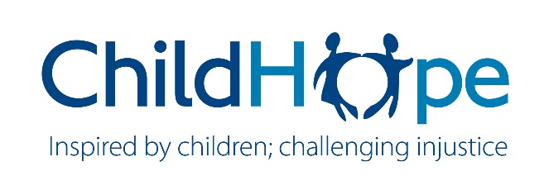
TERMS OF REFERENCE
CONSULTANCY ROLE | FUNDRAISING CONSULTANT
OVERALL PURPOSE | To produce high quality bids to secure income from Trusts & Foundations
CONTRACT | 15 days, with potential to extend following review

Introduction:
ChildHope believes that children should enjoy a safe and secure childhood, but for those growing up in the toughest circumstances, these rights are denied. ChildHope’s work addresses some of the most challenging issues facing children and families around the world today, including modern day slavery and trafficking, gender inequality and dangerous working conditions. The children we work with may live and work on the street, be at risk of trafficking or child marriage, be survivors of abuse or sexual exploitation, or be working on rubbish dumps. Children with disabilities are even more likely to be stigmatised, abused, exploited or neglected.
ChildHope develops and delivers programmes by working in partnership with local organisations, thus avoiding imposing unsuitable ‘outsider’ solutions on local issues. ChildHope’s contribution to partners outside the delivery of projects includes working with them to secure and manage funding and to further develop their own organisational systems and processes.
ChildHope has established effective methods to secure large institutional grants from donors, a role which is delivered mainly by our Partnerships and Programmes Team. We also secure smaller, unrestricted donations via a range of sources, including individuals, corporates and trusts and foundations. This is carried out by our Fundraising and Communications Team.
We have identified an additional need and opportunity - to apply for medium-sized (range approx. £20k - £100k each) grants and donations from trusts and foundations. ChildHope is looking for additional capacity to prepare and submit these applications.
Principle Objectives of the Assignment

ChildHope is looking for an experienced and skilled Trusts and Foundations Fundraiser - somebody familiar with children’s rights work in the international development sector – to successfully secure further unrestricted and restricted/project income from trusts and foundations.

The assignment will involve
- Becoming rapidly familiar with ChildHope’s work and funding needs (via reading and online meetings)
- Reviewing our current pipeline of potential opportunities
- Researching further potential opportunities and growing our pipeline
- Shortlisting strong potential income sources, prioritizing those with high capacity to give unrestricted donations or core funding
- Completing and submitting at least £100k worth of applications
Support you can expect from ChildHope to fulfil the Assignment

- Materials describing the work
- Introductory meetings to enable familiarity with our work
- Access to team members to discuss ideas and approaches that will help strengthen applications – including meetings with partners as appropriate
- Support with reviewing applications prior to submission
- Access to our existing pipeline and discussion with relevant team members
Who we are looking for – Person Specification

- An experienced fundraiser who has specialized in trusts and foundations; additional experience of corporate T&F fundraising, newspaper and media appeals would be a distinct advantage
- Experience of fundraising for children’s rights organisations in the international development sector, with experience of working with small to medium sized organisations
- A natural and confident networker with excellent interpersonal skills, but equally able to work independently
- A proven track record of achieving agreed targets and objectives against plans
- Commitment to international development, children’s rights, gender equality and disability inclusion
- The scope to dedicate at least two days per week to this assignment until its completion

Note: The successful candidate will be expected to read ChildHope’s Safeguarding Policy and sign up to our Code of Conduct. The recruitment/reference process also includes questions regarding safeguarding and child protection.

Expression of Interest

If you are interested, we are looking for an expression of interest of maximum 2 pages, including
- An outline of how you would carry out the task with clear numbers of days against specific activities and a timeline, with a proposed start date (maximum 15 days total)
- An overview of your experience and why you are suitable for this role, including some examples of funding you have secured from Trusts and Foundations (name of T/F, amount secured, when)
- A minimum of two recent references (please note we may contact them for verbal as well as written feedback, but will check with you beforehand)
- The rates you would charge for this assignment
- Please also include at least one example of a successful bid you submitted to a trust or foundation that you feel helps to illustrate your ability to carry out this assignment.
Deadline for submission of Expression of Interest:
Friday 10th July, 5pm. Please send to info@childhope.org.uk

